Fear of Failing
November 18, 2017
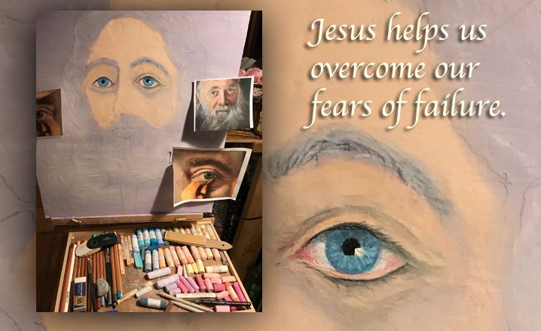
Lord Jesus, we need courage. Help us to think WAY outside the box on what You can do if only we will say yes!!! Amen.

Well, dear friends, the Lord has wanted me to do a portrait of His Father for weeks. And today, I was encouraging one of our very dear friends to begin to paint faces, not just flowers. She just started painting not very long ago.

So, I asked her to start painting faces, but she is afraid of failing. I told her 'Nothing ventured, nothing gained.' You don't have to show your bad stuff...how can you learn if you don't work past your limitations? There is SO much you can say when you have no limitations and can draw a child's face, or an old man's face. A garden, a cat... Don't put yourself in a box with Jesus. "I'll paint flowers, but not faces. I'll paint trees, but not people.”

Dearest, don't do this to yourself. Open up, take risks! With Jesus, you can't lose. So what if it takes 10 times to get it right...who cares? We're not in a big hurry, perfect your skill. Jesus is so with you.

And then I continued, NEVER BE AFRAID TO FAIL! People who are paralyzed by fear of failure—NEVER GROW!!! They never move into their potential. And certainly, the Lord cannot bring them to a level of mastery, and neither can He use them everywhere He wants to.

So, do it and be fully equipped to serve.

I wanted to read that to you, just so you could kind of be encouraged yourself, if you're working on something and you're afraid to try something new. Don't be afraid. The Lord is leading you, He's given you a gift. He'll help you accomplish it.

So, I asked the Lord, "What is on Your heart tonight?" after the communion service.

And He said, "You are, Beloved."

Well, that's nice! What would be most pleasing to You, Jesus, for me to do with this night?

He didn't hesitate for an instant, "The portrait of My Father."

Really?

"Really and truly. I would have liked to have seen it done a while back, but now is a good time to start. Remember, you are not alone; I and My angels are with you, Clare. I want My children, My people, to understand Who My Father truly is. You have experienced His genuine tenderness. Oh, Clare there is so much more to Him I want you and Heartdwellers to know! So much more. Sometimes, oftentimes, a picture is truly better than a thousand words.

"In His tenderness, He is vulnerable. Very vulnerable. He knows what you are made of, where you stand and where you fall. He gives His angels charge over you, lest you fall in those vulnerable places. He always knows what is next and what is best. He longs to reveal His tender heart, because so many people don't really understand Him. He wants to completely revise their erroneous opinions of Him.

"But He is also pleased that many are more interested in Me, because in Me is His fullness and they can see clearly this vulnerable heart of compassion for all.

"Nevertheless, it is important to disclose His sweetness right beside His powerfulness. It is important for all to understand: His sense of justice is born from ethical standards that are for your good—and He hates to see the alien and the widow mistreated. Anytime the downtrodden are abused, His heart is crushed. And He longs to rush to their rescue.

"He tenderly loves His creatures, and the co-creative process by which the world and its creatures were created—and it grieves Him deeply to see it destroyed. Satan has most carefully targeted the areas that bring Him the most grief.

"Oh, how He loves babies, and feels so deeply grieved by the atrocities committed against them. In fact, the place where aborted babies go is one of the most magnificent areas of Heaven. But you must be a child to appreciate it.

"And then, there is the hard-hearted indifference of men in killing whole forests without a second thought that they and their inhabitants will become extinct, for the sake of greedy personal gain. He suffers enormously when ungodly rulers take control of their people and strip them of their dignity, and even so far as to conquer the poor around them, stealing their land and leaving them homeless.

"The list of atrocities continues to grow every day. I don’t want you to make a statement with this painting other than His tender love for you—and by that, people will see His tender love for them. This is the goal of the portrait, and of course, I want you, Clare, to drink deeply from the overflowing springs of His Heart and love for you.

"Oh, this is so important to Me! I could go on and on about the corruption of fathers, but that wouldn’t do anything but bring up a very sad past.

"I would rather all that look into His eyes see their future with Him in Heaven and how extraordinary His love is for them. You can do this with My help. You can."

Jesus, I believe in You. I trust in You. You can do anything.

He answered me, "Thank you."

